Rainwater tank care: problems and how to correct them
Problem | Cause | Ways to prevention | Observation of problem | Maintenance
H₂S strip test positive (photo below) | Microbial growth in the tank | Screens and filters to prevent leaves entering the tank  Trimming overhanging trees | Check the tank using the H₂S strip test every month | - Disinfect the tank with 5ml of Jik (12.5% sodium hypochlorite) without perfume.  - Trim trees and clean gutters  - Only use water for gardening if not disinfected
Sludge in the tank | Soil particles from the air | Filters or first flush (info at www.ru.ac.za/ environment/resources/water/rainwater) | Soil in the roof | - Clean the tank every 2-3 years
Mosquitos or worms | Stagnant water inside pipe bends or dirty gutters where which mosquitoes laid their eggs or midges laid their eggs | Seal all tank openings, install pipes to prevent water from stagnating | Larvae in the water  Mosquitoes around the tank | - Place screening filters to prevent mosquitoes entering the tanks (like a fine kitchen sieve).  - Clean gutters to prevent stagnant water
Faecal matter on roof or around the tank | Bird and animal droppings, decomposing leaf litter | Prevent opening which allow animals or birds into the tank.  Trim overhanging trees which encourage birds to sit over the roofs | Bird droppings on the roof, soil on the roof  Bird droppings in the tank  Leaves on the roof.  Check tank for dead animals  Positive H₂S strip test result. | - Trim branches over hanging the trees.  - Clean the gutters and the roof  - Inspect regularly  - Check seals on the tank.  - If tanks are contaminated then empty and clean or disinfect the tank
Smelly water due to leaf litter degradation | Trees overhanging the roof.  Degrading vegetation in the tank or soil  Light entering the tank causing algal growth | Use leaf excluders  Clean gutters and use filters | The smell or colour of the water  Visible leaves in the tank | - Empty the tank and clean it with non-perfumed Jik or sodium hypochlorite  - Ensure no light is entering the tank  - Clean the leaf litter excluders/ filters.  - Clean the gutters  - If lots of leaves are present in the tank then clean the tank
Coloured water | Degradation of painted roofs, tiles.  Resuspended sediment | Maintain the roof | A difference in colour between the rainwater and the tank water.  Slime on the inside of the tank  Small white flakes | - Remove sediment from the tank  - Repaint roof if it is degrading with lead free paint  - Clean the tank and disinfect it.
Photo showing the H₂S strip test:

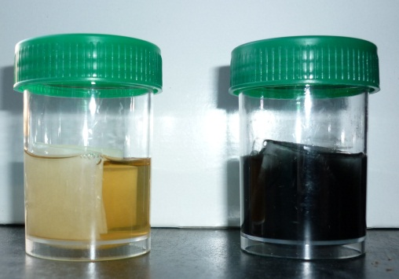
Negative result (Left) = pale/yellow.

Positive result* (Right) = dark/black. This indicates that bacteria are present, so the water is not suitable for drinking.

*Further detailed lab tests by the Environmental Health and Biotechnology (EHB) Research Group at RU Faculty of Pharmacy will provide more accurate information – please contact Roman Tandlich on roman.tandlich@gmail.com; r.tandlich@ru.ac.za; cc safety@ru.ac.za - for follow-up.

